**Objective**: Learning about different types of locks and how to use and release locks.

**Locks:** Locks are mechanisms used to ensure data integrity while allowing maximum concurrent access to data. The Oracle engine automatically locks table data while executing SQL statements. This type of locking is called Implicit Locking.

**Types of locks:** The type of lock to be placed on a resource depends on the operation being performed on that resource. Operations on tables can be distinctly grouped into the following two categories:

1. Read Operations: SELECT statement.
2. Write Operations: INSERT, UPDATE, DELETE statements.

**The rules of locking is:**

1. DATA being CHANGED cannot be READ.
2. Writers wait for other writers if they attempt to update the same rows at the same time.

**The two types locks supported by Oracle are:**

1. **Shared Locks:**

* Shared locks are placed on resources whenever Read operation (SELECT) is performed.
* Multiple shared locks can be simultaneously set on a resource.

1. **Exclusive Locks:**

* Exclusive locks are placed on resources whenever Write operations (INSERT, UPDATE and DELETE) are performed.
* Only one exclusive lock can be placed on a resource at a time.

**Create lock using LOCK TABLE statement:**

**Syntax:**

LOCK TABLE <TableName> [,<TableName>]….

IN {ROW SHARE | ROW EXCLUSIVE | SHARE UPDATE | SHARE | SHARE ROW EXCLUSIVE | EXCLUSIVE}

[NOWAIT]

**Meaning of the keywords:**

|  |  |
| --- | --- |
| TableName | Indicates the name of the table, view to be locked. |
| IN | Decides what other locks on the same resource can exist simultaneously. It can have the following values: |
| **Exclusive:** They allow query on the locked resource but prohibit any other activity. |
| **Share:** It allows queries but prohibits updates to a table. |
| **Row Exclusive:** Row Exclusive locks are the same as row share locks also prohibit locking in shared mode. These locks are acquired when updating, inserting or deleting. |
| **Share Row Exclusive:** They are used to look at a whole table, to selective updates and to allow other users to look at rows in the table but not lock the table in share mode or to update rows. |
| NOWAIT | Indicates that the Oracle engine should immediately return to the user with a message, if the resource are busy. If omitted, the Oracle engine will wait till resources are available forever. |

**Example:**

Two client machine Client A and Client B are performing data manipulation on the table student.

**Table name:** student

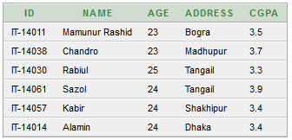

Client A has locked the table in exclusive mode (only querying of records is allowed on the student table by Client B).

**Client A>** LOCK TABLE student IN EXCLUSIVE Mode NOWAIT;

Client A performs an insert operation but does not commit the transaction:

**Client A>** INSERT INTO student VALUES('IT-14056','Bellal', 27, 'Tangail', 3.60);

Client B performs a view operation:

**Client B>** SELECT *FROM student;

Output:

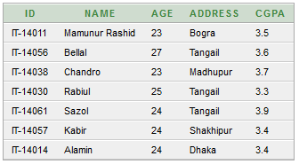

Client B performs an insert operation:

**Client B>** INSERT INTO student VALUES('IT-14042','Rashed', 25, 'Gaibandha', 3.70);

**Output:**

Client B’s SQL DML enters into a wait state waiting for Client A to release the locked resource by using a Commit or Rollback statement.

**Releasing Locks:**

Locks are released under the following circumstances:

1. The transaction is committed successfully using the COMMIT verb.
2. A Rollback is performed.
3. A Rollback to a savepoint will release locks set after the specified savepoint.